LIBRARY MANAGEMENT SYSTEM

GROUP: ANONYMOUS

APURV H SHAH

YATINBHAI A PATEL

MONROE COLLEGE

# ER DiagramMacintosh HD:Users:basantarai:Downloads:librarary_management.pdf

# Database Design

CREATE TABLE LIBRARIAN

(

Librarian\_id Number,

Firstname VARCHAR(30),

Lastname VARCHAR(30),

Password VARCHAR(30)

);

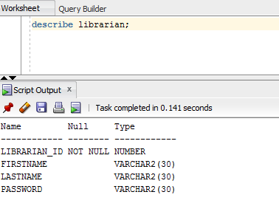

ALTER TABLE LIBRARIAN

ADD PRIMARY KEY(Librarian\_id)

INSERT INTO LIBRARIAN (Librarian\_id, Firstname, Lastname, Password)

VALUES ('1','Yash','Mistry','1111');

INSERT INTO LIBRARIAN (Librarian\_id, Firstname, Lastname, Password)

VALUES ('2','Apurv','Shah','2222');

INSERT INTO LIBRARIAN (Librarian\_id, Firstname, Lastname, Password)

VALUES ('3','Basanta','Ray','3333');

INSERT INTO LIBRARIAN (Librarian\_id, Firstname, Lastname, Password)

VALUES ('4','Raza','Patel','4444');

INSERT INTO LIBRARIAN (Librarian\_id, Firstname, Lastname, Password)

VALUES ('5','Devins','Shah','5555');

CREATE TABLE MEMBERSHIP

(

Membership\_id NUMBER,

Membershiptype VARCHAR(30)

);

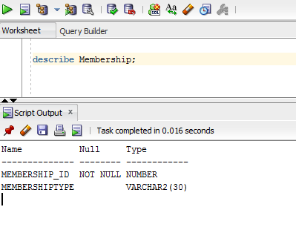

CREATE TABLE BORROWED\_TRANSACTION

(

Transaction\_id NUMBER,

Book\_id NUMBER,

Member\_id NUMBER,

CreatedBy VARCHAR(30),

BorrowedDate DATE

);

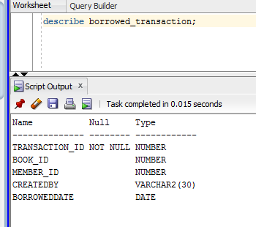

insert into Borrowed\_Transaction(transaction\_id,book\_id,member\_id,createdby,borroweddate)

Values('123','2001','110','Yash','20-Aug-2016');

insert into Borrowed\_Transaction(transaction\_id,book\_id,member\_id,createdby,borroweddate)

Values('124','2002','120','Deavin','02-Sep-2017');

insert into Borrowed\_Transaction(transaction\_id,book\_id,member\_id,createdby,borroweddate)

Values('125','2003','130','Amit','27-Jan-2017');

insert into Borrowed\_Transaction(transaction\_id,book\_id,member\_id,createdby,borroweddate)

Values('126','2004','140','Yatin','14-Feb-2017');

CREATE TABLE MEMBER

(

Member\_id NUMBER,

Membership\_id NUMBER,

CreatedBy VARCHAR(30),

Firstname VARCHAR(30),

Lastname VARCHAR(30),

Email VARCHAR(30),

MemberStatus VARCHAR(30),

ExpiredOn DATE

)

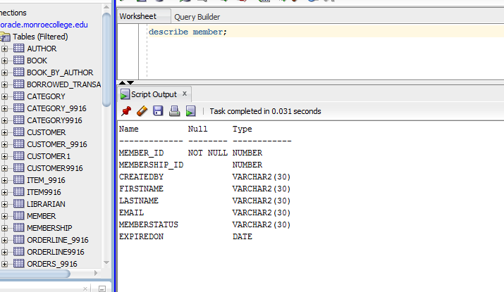

insert into member(member\_id,membership\_id,createdby,firstname,lastname,email,memberstatus,expiredon)

Values ('2001','1001','Yash','AAA','Patel','AAA@gmail.com','Platinum','26-Dec-2016');

insert into member(member\_id,membership\_id,createdby,firstname,lastname,email,memberstatus,expiredon)

Values ('2002','1002','Amit','BBB','Patel','BBB@gmail.com','Silver','15-Dec-2016');

insert into member(member\_id,membership\_id,createdby,firstname,lastname,email,memberstatus,expiredon)

Values ('2003','1003','Yatin','CCC','Patel','CCC@gmail.com','Gold','11-Dec-2016');

insert into member(member\_id,membership\_id,createdby,firstname,lastname,email,memberstatus,expiredon)

Values ('2004','1004','Deavin','DDD','Patel','DDD@gmail.com','Platinum','31-Dec-2016');

CREATE TABLE BOOK

(

Book\_id NUMBER,

Publish\_id NUMBER,

Category\_id NUMBER,

Author\_id NUMBER,

BookName VARCHAR(30),

Edition VARCHAR(30),

BOOKCopies NUMBER

)

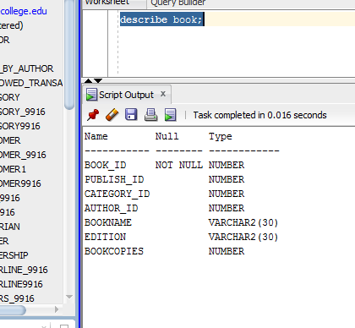

insert into Book(book\_id,publish\_id,category\_id,author\_id,bookname,edition,bookcopies)

Values('2001','001','11','1001','Database','Sixth','11');

insert into Book(book\_id,publish\_id,category\_id,author\_id,bookname,edition,bookcopies)

Values('2002','002','12','1002','Algorithms','Fifth','09');

insert into Book(book\_id,publish\_id,category\_id,author\_id,bookname,edition,bookcopies)

Values('2003','003','13','1003','Code Complete','Seventh','12');

insert into Book(book\_id,publish\_id,category\_id,author\_id,bookname,edition,bookcopies)

Values('2004','004','14','1004','Operating System','Sixth','08');

CREATE TABLE PUBLISHER

(

Publish\_id NUMBER,

Name VARCHAR(30),

ContactNO NUMBER,

Email VARCHAR(30),

City VARCHAR(30),

State VARCHAR(30)

)

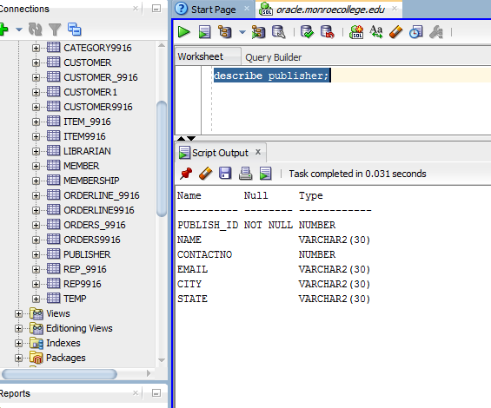

CREATE TABLE CATEGORY

(

Category\_id NUMBER,

Name VARCHAR(30)

)

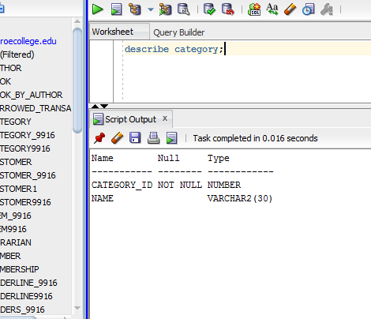

insert into Category(category\_id,name)

Values('11','Yash');

insert into Category(category\_id,name)

Values('12','Basant');

insert into Category(category\_id,name)

Values('13','Amit');

insert into Category(category\_id,name)

Values('14','Yatin');

insert into Category(category\_id,name)

Values('15','Devin');

CREATE TABLE BOOK\_BY\_AUTHOR

(

Author\_id Number,

Book\_Id Number

)

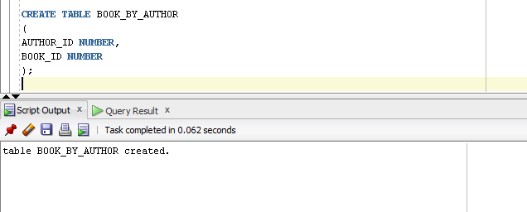

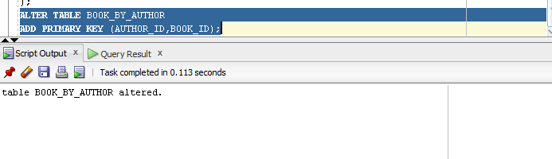

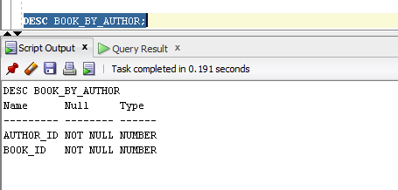

insert into Book\_By\_Author

Values('1001','2001');

insert into Book\_By\_Author

Values('1002','2002');

insert into Book\_By\_Author

Values('1003','2003');

insert into Book\_By\_Author

Values('1004','2004');

CREATE TABLE AUTHOR

(

Author\_id NUMBER,

FirstName VARCHAR(30),

LastName VARCHAR(30)

)

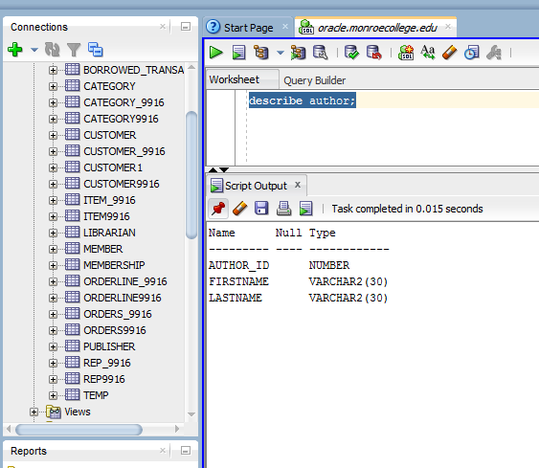

insert into author

Values('1001','Yash','Mistry');

insert into author

Values('1002','Amit','Patel');

insert into author

Values('1003','Devid','Rajpara');

insert into author

Values('1004','Birju','Mistry');

* 1. Create Join

Select member.lastname || ',' || member.firstname member,

membership.membershiptype membership, borrowed\_transaction.transaction\_Id borrowed\_transaction

from member,membership,borrowed\_transaction

where member.member\_id = membership.membership\_id

AND member.membership\_id = borrowed\_transaction.transaction\_id;

* 1. Create View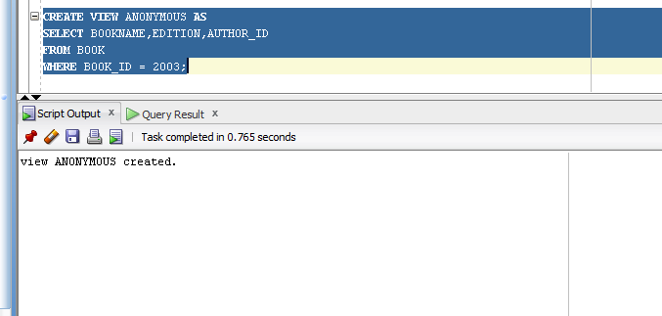
  2. Create Synonym

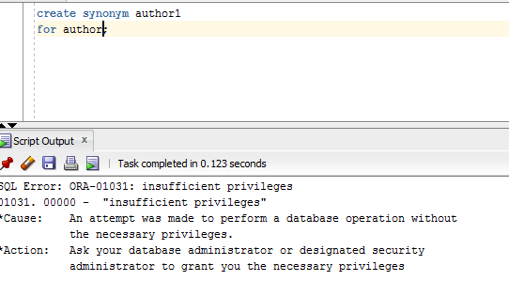

* 1. Create Index

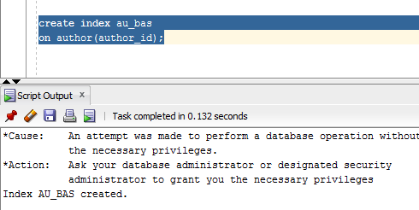

* 1. Create Sequence

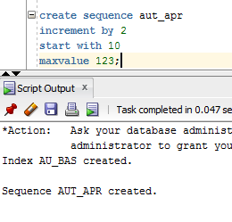

* 1. Create Procedure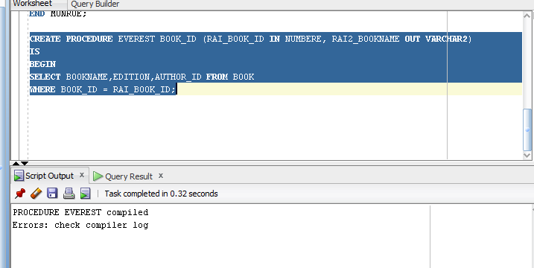
  2. Create Function

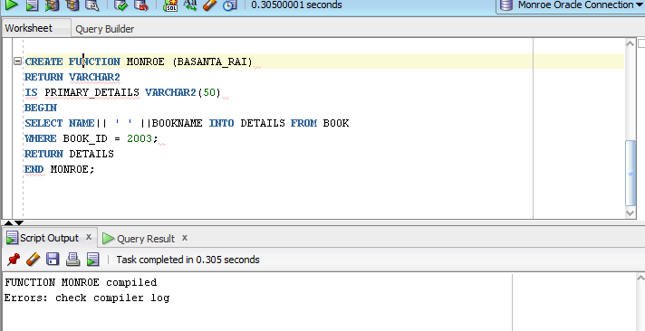

# Conclusion

In conclusion , this second ASSIGNMENT helped us to create different table along with inserting composite keys and joining different tables. Similarly it also helped us to familiar with PL/SQL commands where we have implemented procedures and functions in the assignment.